

FPT ACADEMY INTERNATIONAL
FPT – APTECH COMPUTER EDUCATION

StarOrganic.com

Team: Group 2

Le Cong Dat (Team Leader) Student1022144
Tran Thi Tuyet Duyen Student1030933
Nguyen Le Hai Long Student1053744
Tran Tan Duy Student1053750

Instructor:

Dao Ngoc Anh

November - 2017
Description:

- Homepage displays a few top famous bridges with short description about their features. Some advertisements will all so be shown on this page.
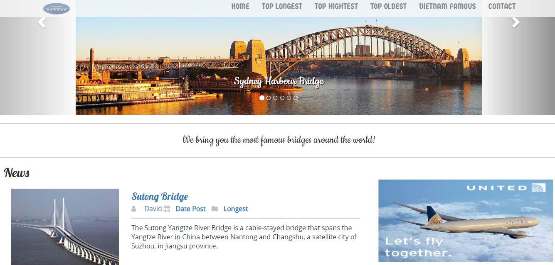
……………………………………………………………………………………………………………………………………………….
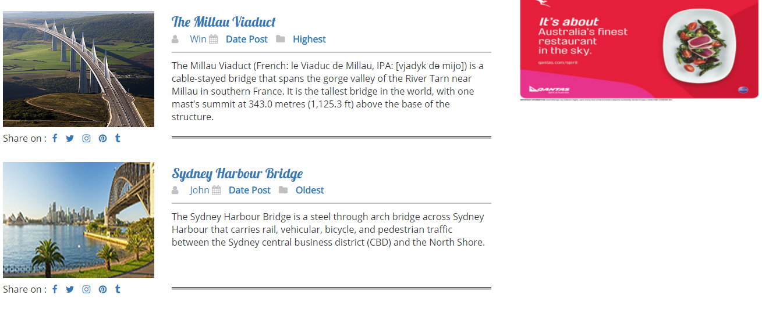
……………………………………………………………………………………………………………………………………………….
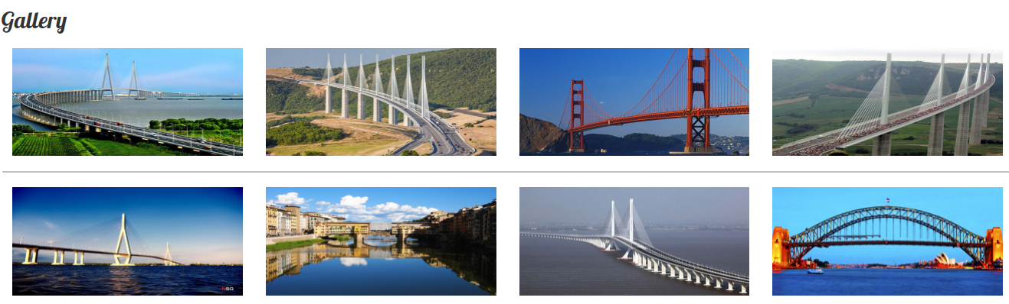

- Top Longest page presents short briefs of top longest bridgest around the world. If users want to have more information about a particular bridge, they can click on the image next to the description paragraph. It will then open up a detail page about that bridge.
- Top Highest page shows short briefs of top highest bridgest around the world. If users want to have more information about a particular bridge, they can click on the image next to the description paragraph. It will then open up a detail page about that bridge.
- Top Oldest page provides short briefs of top oldest bridgest around the world. If users want to have more information about a particular bridge, they can click on the image next to the description paragraph. It will then open up a detail page about that bridge.
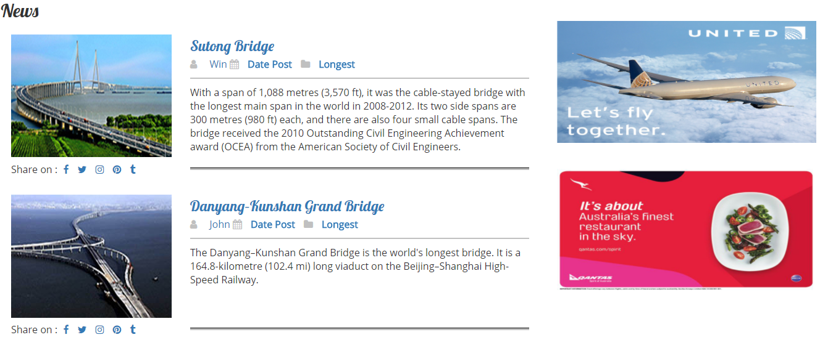
- World famous page includes short briefs of world famous bridges.
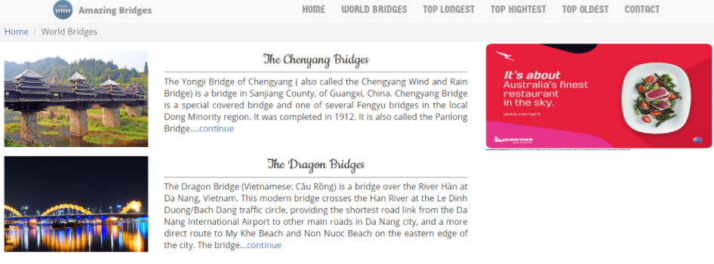
- Detail page displays full description of a specific bridge. More images of that bridge will be presented in the gallery. In addition, there is comment section which visitors can give feedback to AmazingBridges.com for improving purpose; they can also find usefull information which may help them get to the place.
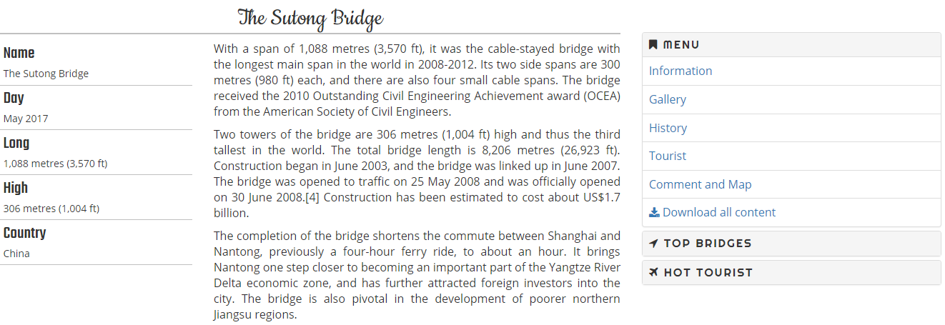
……………………………………………………………………………………………………………………………………………….
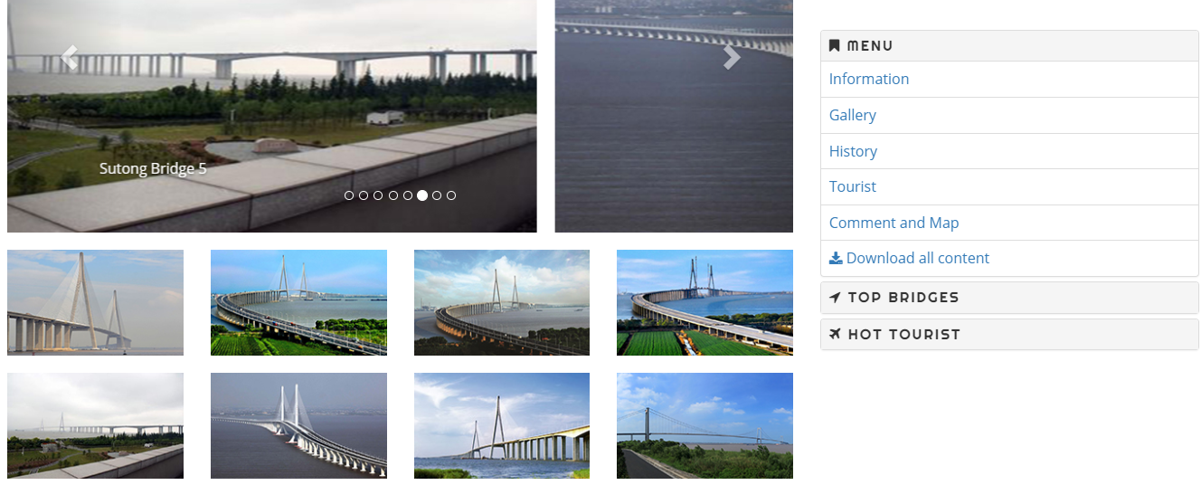
……………………………………………………………………………………………………………………………………………….
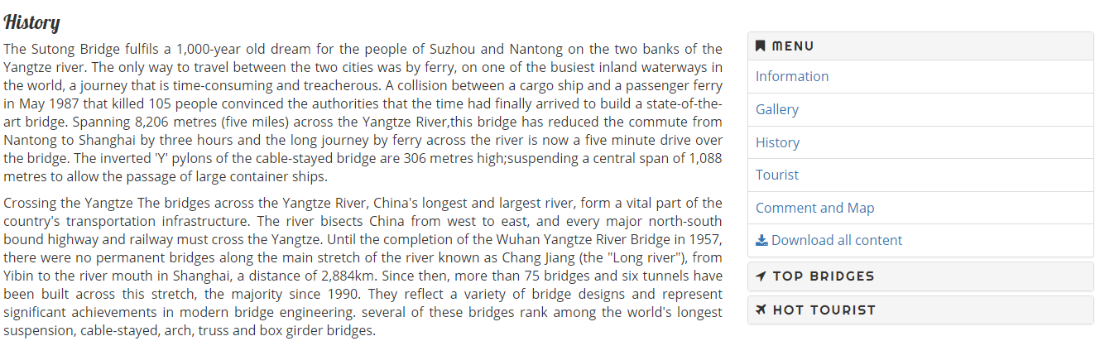
……………………………………………………………………………………………………………………………………………….

……………………………………………………………………………………………………………………………………………….
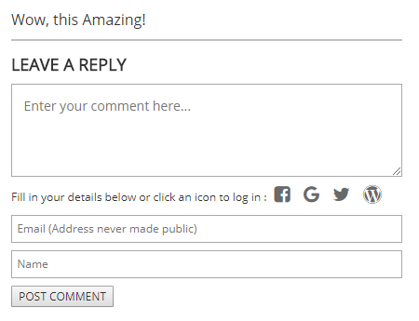
- FAQ gives visitors some helpful hints about what they are looking for by providing common sample answers.
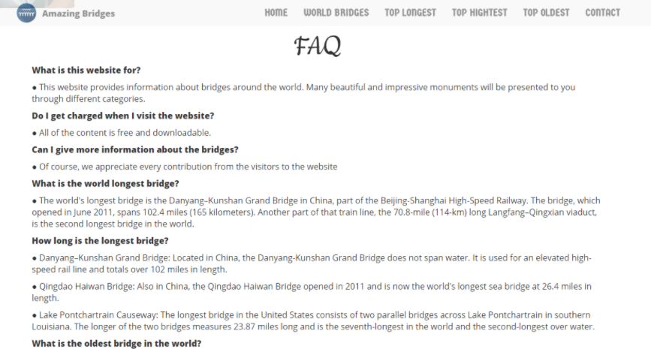

- Contact : Visitors can get in touch with AmazingBridges.com via email or phone number on the page.
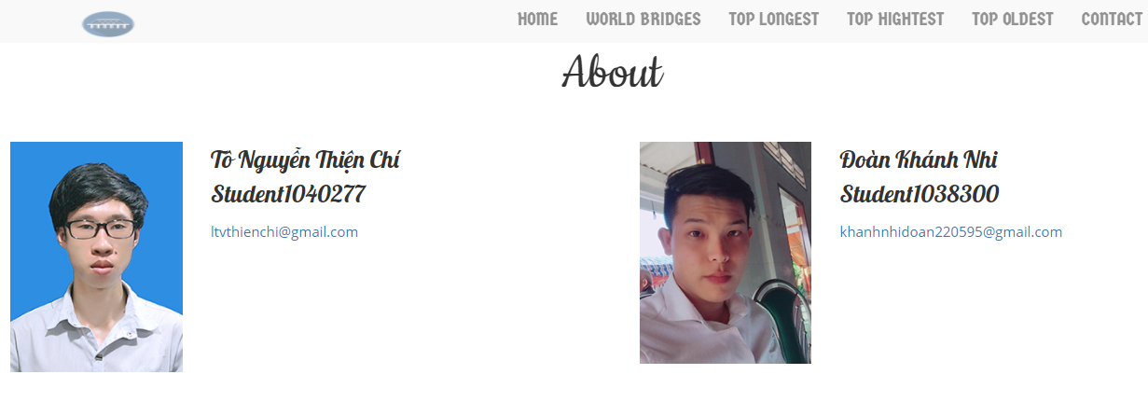

TASK SHEET REVIEW 3

No | Page Name | Begin Date | TeamMate Name | Notes
01 | Homepage | 9/16/2017 | Minh
02 | Top Longest | 9/16/2017 | Ngoc
03 | Top Highest | 9/16/2017 | Ngoc
04 | Top Oldest | 9/16/2017 | Nhi
05 | Vietnam Famous | 9/16/2017 | Nhi
06 | Contact/about/FAQ | 9/16/2017 | Chi
07 | Detail pages | 9/16/2017 | Chi

Date:
Signature of Instructor:  Le Mong Thuy | Signature of Team Leader:  Nguyen Huu Minh

